JAVA

HOW TO DISPLAY THE OUTPUT IN JAVA:-

package com.ayush;  
  
public class Main {  
  
 public static void main(String[] args) {  
 // write your code here  
 System.*out*.println("hello world");  
 System.*out*.println("wh");

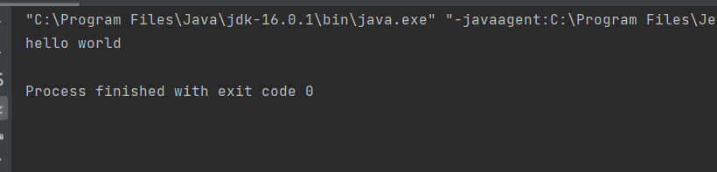

Concentered the string

package com.ayush;  
  
public class type {  
 public static void main(String[] args) {  
//byte age =30;  
// long phone= 154141447204515L;  
// float pi =3.14F;  
// char letter='@';  
// boolean isAdult= true;  
// boolean isAdult= false;  
 //non primitive type  
 String name="AYUSHJ";  
  
 String name1= "aman";  
 String name2 = "asdjn";  
 String name3 = name + " and " +name2;  
 System.*out*.println(name3);  
  
 }  
}

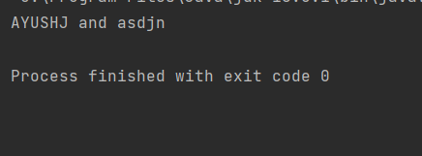

package com.ayush;  
  
public class Main {  
  
 public static void main(String[] args) {  
 int i = 0;  
 while (true) {  
  
 System.*out*.println(i);  
 i = i + 1;  
 if (i == 3) {  
 i = i + 1;  
 continue;  
 }  
  
 if (i > 5) {  
 break;  
 }  
 }  
 }  
}

OUTPUT:-

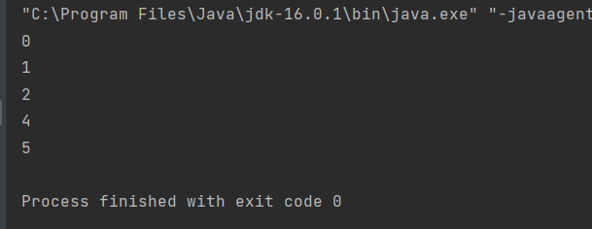

mini project:-

package com.ayush;  
  
import java.util.Scanner;  
  
public class Main {  
 public static void main(String[] args) {  
 Scanner sc= new Scanner(System.*in*);  
 int myNumber=(int)(Math.*random*()*100);  
 int userNumber=0;  
 do {  
 System.*out*.print("Guess the Number(0-100): ");  
 userNumber = sc.nextInt();  
 if (userNumber == myNumber) {  
 System.*out*.println("Wow You guess the current answer");  
 break;  
 }else if (userNumber > myNumber) {  
 System.*out*.println("You number is too lager");  
 }else {  
 System.*out*.println("Your number is too small");  
 }  
 }while (userNumber>=0);  
  
 }  
 }

OUTPUT:-

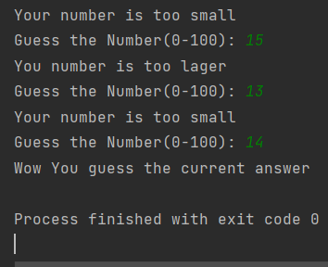

**Copy constructor**

